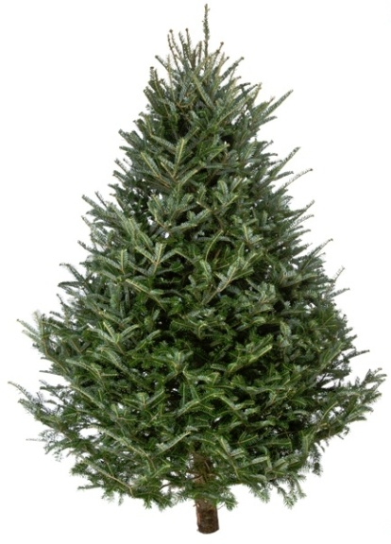

**All Enquiries: Contact Dominic**

**mobile: 07753 606081**

**email:** [**dominic@perfectscent.co.uk**](mailto:dominic@perfectscent.co.uk) **Proud Donators of the**

**School’s Christmas Tree**

PERFECT**SCENT**



**Christmas Tree Order Form**

**Nordman Fir Non-Drop Variety**

**Free Local Delivery Beautiful Shape Delightful Aroma**

I would like to order

|  |  |  |  |
| --- | --- | --- | --- |
| Item | Quantity | Cost | Total Cost |
| Potted Trees 3-4ft |  | £30 |  |
| 5/6ft Tree |  | £43 |  |
| 6/7ft Tree |  | £53 |  |
| 7/8ft Tree |  | £66 |  |
| For Taller than 8ft |  | Please enquire for prices |  |
| Xmas Tree Stand (inc water reservoir) |  | £20 |  |
| TOTAL COST | | |  |

Payment Options: ❒ Cash on delivery

❒ Online in advance (preferred): Please quote your surname as a reference

Perfect Scent Flowers & Plants Ltd.

Sort Code: 09-06-66 Account Number: 41184068

Please scan or photo this form, and return to [dominic@perfectscent.co.uk](mailto:dominic@perfectscent.co.uk) by Thursday 3rd December 2020.

Thank you and Merry Christmas

Dominic & the Team

Name _______________________________________________________________

Address ____________________________________________________________________

___________________________________________________________________________

Mobile____________________________ Email address: ___________________________

Due to COVID cancelling the School Christmas Fair, Christmas tree deliveries will be made on Saturday 5th December 2020